







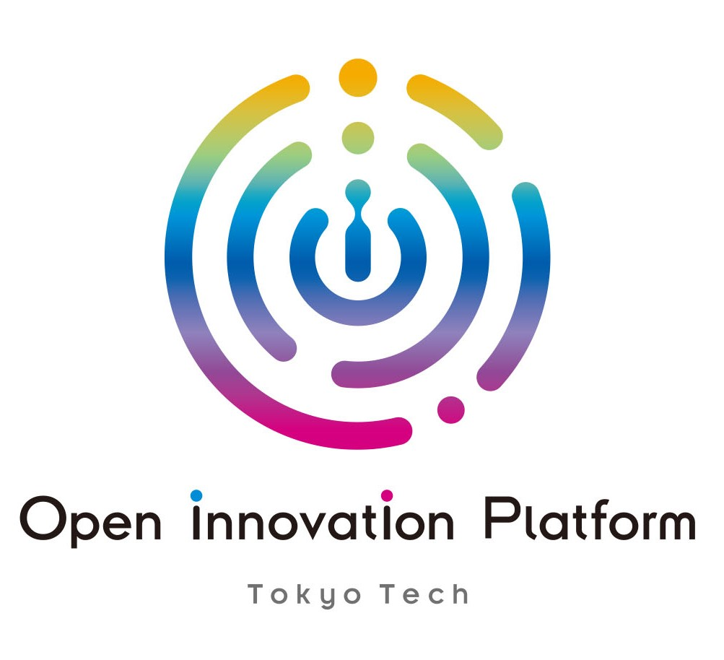

12th imec Handai International Symposium
November 8(Wednesday) ,2023 ＠SANKEN, Osaka University, Osaka, Japan
MC: Bernard Grundlehner, Mototsugu Ogura
Time(CET) | Presentation title | Speakers | Title | Affiliation
9:30-9:40 | Welcome word | Tohru Sekino | Director | SANKEN
9:30-9:40 | Welcome word | Yoichi Oshima | Vice president | Tokyo Tech
9:40-10:00 | Keynote speech： | Chris Van Hoof | Vice president | imec
10:00-10:20 | Keynote speech: SANKEN Activity Overview, and Nanostructured Inorganic Materials for Multifunctional Application | Tohru Sekino | Director | SANKEN
Session1 | Nano, bio electronics, semiconductors
10:20-10:30 | (online) 3D packaging technologies |  |  | imec
10:30-10:45 | Advanced semiconductor packaging technology for automotive applications | Katsuaki Suganuma | Professor | SANKEN
10:45-11:00 | The first application of semiconductor to medicine: Si-based agent | Hikaru Kobayashi | Professor | SANKEN
11:00-11:15 | Ingestible sensors | Rachel Armstrong |  | OnePlanet
11:15-11:30 | Reaction mechanisms of Sn-complex-side-chain polymer used for extreme ultraviolet lithography | Takahiro Kozawa | Professor | SANKEN
11:30-11:45 | Concept for a Digital Transformation of Japanese Food System by Connecting Smart Agriculture and Personalized Well-Being Value Creation for Mental and Physical Health" | Eiichiro Kimura | Professor | Tokyo Tech
11:45-12:00 | Nanowire technology accelerates chemical data collection | Kazuki Nagashima | Professor | Hokkaido Univ.
12:00-13:15 | Networking Lunch
13:15-13:20 | Welcome word | Jo De Boeck | Executive vice president & CSO | imec
Session2 | AI, information processing
13:20-13:35 | Online Energy Management Framework for Smart Buildings with Low-Complexity Estimators | Dafang Zhao | Assistant professor | IST
13:35-13:50 | Identifying second language skills using EEG | Tsukasa Kimura | Assistant Professor | Human Science
13:50-14:00 | (online) Digital twin activities | Santiago Gaitan | Senior researcher | OnePlanet
14:00-14:10 | (online) Smart bathroom | Eva Wentink | Senioｒ researcher | OnePlanet
14:10-14:40 | Networking coffee break
Session3 | Next generation computing
14:40-14:55 | Networking spin qubits in multi-scale | Takafumi Fujita | Associate professor | SANKEN
14:55-15:05 | (online) Quantum computing | Kristiaan De Greve | Sc. Director | imec
15:05-15:15 | (online) Optical computing | Joris van Campenhout | Imec fellow | imec
Session4 | Flexible, organic, wearable electronics
15:15-15:30 |  | Paul Heremans | Senior fellow | imec
15:30-15:45 | Implantable electronics | Bernard Grundlehner | Project leader | imec-NL
15:45-15:55 | (online) Flexible Ultrasound | Xavier Rottenberg | Imec fellow | imec
15:55-16:10 | Ultraflexible Low-Noise Organic Circuits for Wearable Sensors | Takafumi Uemura | Associate professor | SANKEN
16:10-16:25 | Green-light wavelength-selective organic solar cells for agrivoltaics | Yutaka Ie | Professor | SANKEN
16:25-16:30 | Closing remarks | Hidekazu Tanaka | Vice director | SANKEN
16:25-16:30 | Closing remarks | Chris Van Hoof | Vice president | OnePlanet
16:30-18:00 | SANKEN Lab. tours for imec delegation and others | Nagai lab、Nogi lab
18:00 | Adjourn
Sponsored by SANKEN of Osaka University, imec , imec-NL/Holst Centre ,OnePlanet Research Center
Co-hosted by Network Joint Research Center for Materials and Devices, Crossover Alliance to Create the Future with People, Intelligence and Materials

